## **Task 1**: Discovery Flag: Display data-link headers and the application layer data

* **Solution:**

|  |
| --- |
| Sudo snort -de |

* + d: show application data in transit
  + Text

    Description automatically generated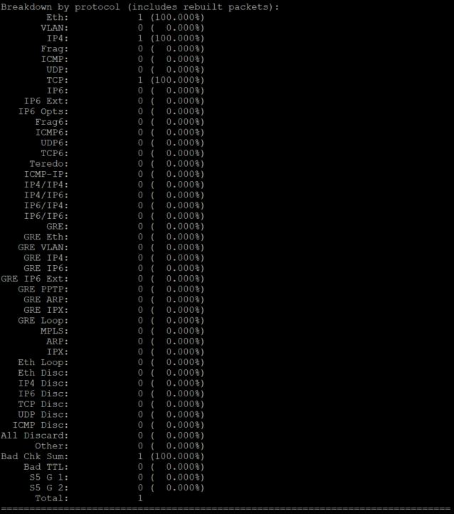e: show the data link layer headers

**research:** http://manual-snort-org.s3-website-us-east-1.amazonaws.com/node4.html

## **Task 2**: Capture only ICMP

* **Solution:**

|  |
| --- |
| Sudo snort -vde icmp |

* + Snort use sniffer mode and apply BPF filter that only retrieve ICMP packet.

## **Task 3:** Check Alerts

**Created Rule:**

Since this rule will generate an alert message for every single captured IP packet that will used up the disk space. And its hard to find the right message as its loaded with alerts if it keeps capture packets

## **Task 4:** Alert for Only ICMP

## **Task 5:** Snort Rule

The subnet 192.168.1.0/24 can send TCP traffic to 192.168.1.0/24 and the port number less and equal than 1024 will not create any alert. Else does.

**TASK 6:** Alert on HTTP Get

Since HTTP clients generally use TCP connections to communicate to the Server, so that we will monitor the TCP traffic. (As my Raspberry pi cannot use browser, so I changed to Kali)

Normally server usually host http request at port 80. So we monitor the destination address with Port 80.

**TASK 7:** Alert on TCP Flags

**Task 8:** Alert on Telnet

